DESCRIPTION:
This orthesis is used for the re-adaptation of the hand of patients who have suffered injuries to ligaments, tendons muscles, and/or skin.

EXERCISES:
The orthesis uses a unique system to create key and precise exercises to the affected fingers. Patients require two distinct orthesis to recover but our product would allow the two exercises to be performed.

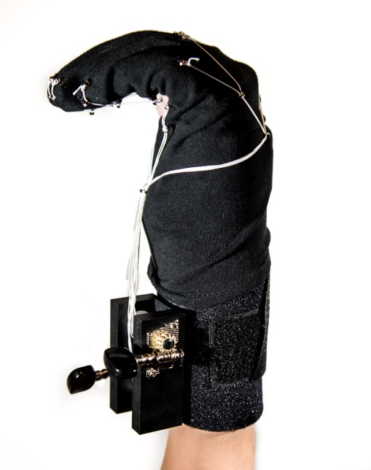 | 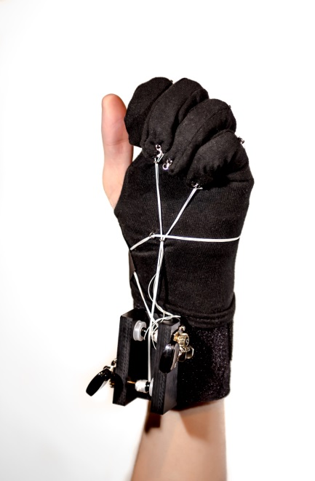
This exercise requires the flexion of the metacarpophalangeal joint | This exercise requires the flexion of the two interphalangeal joints

ADVANTAGES:
    - Reliable pulley system
    - Components easily replaced
    - Flexibility and simplicity
    - Standardization
    - Cost reductions
CONTACT
Kevin.dubord@gmail.com
Phone: 514 262-0871

